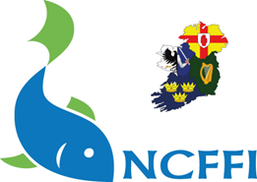
NCFFI Event Report

1. Title of the Event:

2. Name of Club:

3. Location:
Date: Time:

4. Participants
Describe the age group, skill levels and any special needs.

Total No: Male: Female:

5. Summary of Event
Explain the overall purpose and objectives of the event (e.g., to introduce new anglers to the sport, improve angling skills or competition.

No. of coaches:

6. How did the event promote inclusivity?
A diverse group of participants, including beginners, people with disabilities, or underrepresented communities

7. Challenges and Solutions
Identify any challenges that arose before, during, or after the event (e.g., weather conditions, equipment shortages, logistical issues) and how they were addressed.

8. Lessons Learned
Describe what worked well and what could be improved.

9. Conclusion
Summarize the overall success of the event and how it contributed to the growth of coarse angling.

10. Future Plans
Outline the next steps for future events or ongoing engagement with the participants. For example, plans for follow-up coaching sessions, competitions, and club membership.

11. Supporting Media
Attach photographs that capture key moments of the coaching day/camp.

Please forward by email to cado@ncffi.ie or complete online at https://www.ncffi.ie/event-report-form/

